**Kalpataru Vista**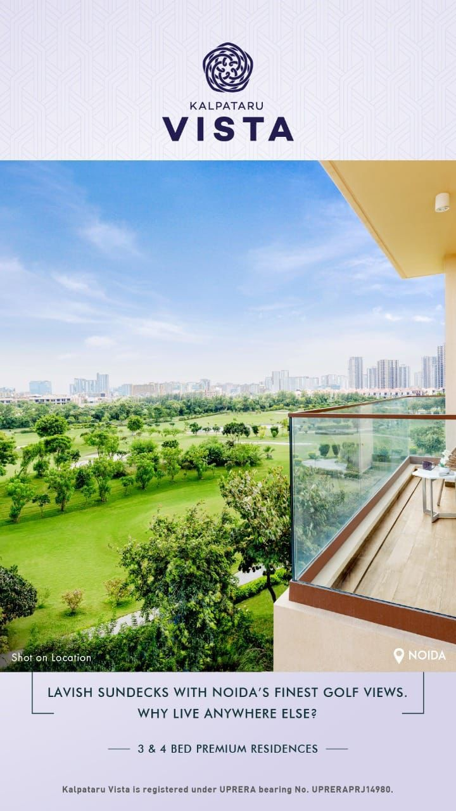

* **Overview**
* **Developer**: Kalpataru Limited
* **Project Name**: Kalpataru Vista
* **RERA Registration**: UPRERAPRJ14980
* **Project Size**: ~2.7 acres (approx. 10,920 sq.m)
* **Towers & Units**: 2 towers (G+30 & G+34), ~252 units including 3BHK, 4BHK & Duplexes
* **Architecture & Theme**
* Contemporary **luxury high-rise design** with a focus on **panoramic golf-course views**.
* Modern elevation with glass façades, grand entrance lobbies, and VRV air-conditioning systems.
* Emphasis on open layouts, large balconies/sundecks, imported Italian marble flooring, and international-style kitchens.
* ~70% **open/green area** ensuring ventilation, natural light, and premium lifestyle.
* **Apartment Configurations & Pricing**
* **3 BHK** – ~3000–3047 sq. ft – approx. ₹5.42–6.5 Cr (₹26,500–27,000 per sq.ft)
* **4 BHK** – ~3905–4145 sq. ft – approx. ₹7.03–8.9 Cr (₹26,500–27,000 per sq.ft)
* **Duplex** – Limited units (~3,500+ sq. ft) – pricing on request  
  *(Prices vary across builder quotes, portals & resale – some resale listings show ₹2.69–4 Cr onwards.)*
* **Amenities & Lifestyle Features**
* **Club Vista** – 45,000 sq.ft premium clubhouse
* **Leisure & Wellness**: Infinity swimming pool, gym, spa, open-air jacuzzi, yoga deck
* **Recreation**: Squash & tennis courts, multipurpose hall, indoor games lounge, jogging/cycling tracks
* **Family & Community**: Kids’ play zone, creche, reading lounge, landscaped gardens, amphitheatre
* **Other Facilities**: 620 car parks, CCTV surveillance, power backup, concierge, business lounge
* **Location & Connectivity**
* **Address**: Sector 128, Noida – Noida–Greater Noida Expressway
* **Connectivity**:
  + ~5 mins from Okhla Bird Sanctuary Metro Station
  + ~15–20 mins from Noida–Delhi border
  + ~25–30 mins to South Delhi, Ghaziabad, Faridabad
  + ~30 km from IGI Airport, ~61 km from upcoming Jewar Airport
* **Nearby Landmarks**: Amity University, Jaypee Hospital, Lotus Valley International School, HCL IT Hub, DLF & Mall of India
* **Summary Table**

|  |  |
| --- | --- |
| **Feature** | **Details** |
| **Developer** | Kalpataru Limited |
| **Project Name** | Kalpataru Vista |
| **RERA ID** | UPRERAPRJ14980 |
| **Land Area** | ~2.7 acres |
| **Units** | ~252 (3BHK, 4BHK, Duplex) |
| **Towers** | 2 (30 & 34 floors) |
| **Architecture** | Modern high-rise, glass façade, golf-course views |
| **Pricing** | ₹5.4–7.5 Cr (average ₹26.5–27K per sq.ft) |
| **Amenities** | Clubhouse, infinity pool, sports, spa, business lounge |
| **Connectivity** | Expressway, Metro, Airport, IT hubs & institutions |
| **Possession** | Expected by June 2025 (some phases by late 2024) |

* **Internal Comparison – Kalpataru Vista Floor Plans**

|  |  |  |  |  |  |  |  |
| --- | --- | --- | --- | --- | --- | --- | --- |
| **Unit Type** | **Super Area** | **Built Up Area** | **Bedrooms** | **Bathrooms** | **Balconies / Sundecks** | **Servant Room** | **Best For** |
| **Type A (3 BHK)** | ~3000–3047 sq. ft | ~2,031 sq.ft | 3 | 4 | 2–3 large sundecks | No | Small families / couples |
| **Type B (3 BHK Premium)** | ~3000–3047 sq. ft | ~2,100–2,200 sq.ft | 3 | 5 | 3 sundecks | Yes (in select layouts) | Families wanting spacious 3BHK |
| **Type C (4 BHK)** | ~3905–4145 sq. ft | ~2,763 sq.ft | 4 | 6 | 3–4 sundecks | Yes | Larger families needing space |
| **Type D (Duplex)** | ~3,500–3,700 sq.ft | ~3,500–3,700 sq.ft | 4–5 | 5+ | Multiple | Yes | Luxury buyers, NRIs, HNIs |

* **Efficiency Ratio (Carpet ÷ Super Area)**
* **Type A (3 BHK)**: ~61–63%
* **Type B (3 BHK Premium)**: ~62%
* **Type C (4 BHK)**: ~58–60%
* **Type D (Duplex)**: ~57–58%

**Observation**:

* 3 BHK units (Type A/B) offer the **highest efficiency** in usable space.
* 4 BHKs & Duplexes are more **luxury-driven** with larger sundecks & premium layout, but slightly lower efficiency.
* **Pricing Snapshot (Indicative)**

|  |  |  |  |
| --- | --- | --- | --- |
| **Unit Type** | **Size Range (sq.ft)** | **Approx. Price Range** | **Per Sq.Ft (Saleable)** |
| 3 BHK | 2,007–2,031 | ₹5.42–6.5 Cr | ₹26,500–27,000 |
| 4 BHK | 2,603–2,763 | ₹7.03–8.9 Cr | ₹26,500–27,000 |
| Duplex | 3,500+ | Price on request (₹9 Cr+) | ~₹26,000+ |

* **Quick Takeaways**
* **Efficiency**: 3 BHK is best for value-conscious buyers.
* **Luxury & Prestige**: Duplex & 4 BHK units cater to HNIs and long-term premium investors.
* **Resale / Investment**: Lower floors may offer better efficiency, while higher floors fetch higher resale due to golf-course views.
* **Current Price Overview**

**1. Builder / Primary Market (Housing.com, official sources)**

* **3 BHK (2,007–2,031 sq.ft)** → ₹5.42–6.5 Cr → ~₹26,500–27,000 per sq.ft
* **4 BHK (2,603–2,763 sq.ft)** → ₹7.03–8.9 Cr → ~₹26,500–27,000 per sq.ft
* **Duplex (3,500+ sq.ft)** → Price on request (~₹9–10.5 Cr) → ~₹26,000+ per sq.ft

**2. Resale Market (99acres, MagicBricks, NoBroker listings)**

* **3 BHK (2,000 sq.ft approx.)**:
  + ₹4.0 Cr → ~₹20,000 per sq.ft
  + ₹4.6 Cr → ~₹22,500 per sq.ft
* **4 BHK (2,700 sq.ft approx.)**:
  + ₹5.8 Cr → ~₹21,500 per sq.ft
  + ₹6.2 Cr → ~₹22,800 per sq.ft

**3. Market Trend & Appreciation**

* **Primary Market (builder rates)** is steady at ~₹26,500–27,000 per sq.ft.
* **Resale Market** is lower, ranging from **₹20,000–23,000 per sq.ft**, depending on floor height, tower, and payment stage.
* Price appreciation in the last 2–3 years: ~8–10% annually (sector average).
* **Quick Takeaways**
* **Builder Rate Premium**: Nearly **20–25% higher** than resale market.
* **Resale Advantage**: Buyers save significantly (~₹1–1.5 Cr on average for 3/4 BHK).
* **Investment Edge**: High floors & golf-facing units command the **highest resale premium**.
* **Market Position**: Kalpataru Vista sits in the **ultra-luxury bracket** of Noida, comparable to Gulshan Dynasty & Godrej Woods.
* **Customer Preferences in Buying Apartments**

1. **Floor Preference**

* **High Floors (25th & above)**
* **Preferred by**: Young professionals, NRIs, HNIs, investors
* **Reasons**:
  + Panoramic **golf-course views** (premium resale value)
  + Less dust & traffic noise (important near Noida Expressway)
  + More natural light, ventilation, and privacy
  + Seen as **prestigious & luxurious**
* **Concerns**:
  + Higher temperature in summers (sun exposure)
  + Full dependency on lifts (though Vista has multiple + power backup)
* **Middle Floors (10th–20th)**
* **Preferred by**: Families with kids, working couples, elderly parents
* **Reasons**:
  + Balance of accessibility and views
  + Easier evacuation in emergencies
  + Moderate pricing (lower than top floors, higher than ground)
* **Concerns**:
  + Noise from surrounding apartments
  + Not as premium as top floors
* **Lower Floors (Ground–5th)**
* **Preferred by**: Senior citizens, families with toddlers, pet owners
* **Reasons**:
  + Easy accessibility without lifts
  + Convenient for daily chores, strollers, pets
  + Some units may come with **private garden/terrace (premium feature)**
* **Concerns**:
  + More dust, insects, and road noise
  + Lesser resale value compared to higher floors

1. **Apartment Facing (East vs. West)**

* **East-Facing Units**
* **Preferred by**: Vastu-conscious buyers, traditional families, many NRIs
* **Reasons**:
  + Considered **auspicious in Vastu** (sunrise, positive energy)
  + Brighter in the **morning hours**, cooler in the afternoon
  + Lower AC consumption compared to West-facing flats
* **Resale Value**: Higher demand → better appreciation
* **West-Facing Units**
* **Preferred by**: Younger buyers, modern families who are less Vastu-focused
* **Reasons**:
  + Stronger evening sunlight (good for families active later in the day)
  + Golf-course view availability sometimes dictates choice regardless of facing
  + Usually **priced slightly lower** than East-facing flats (5–10% in luxury projects)
* **Concerns**:
  + Warmer in summers, higher electricity usage for cooling

1. **Other Key Factors Customers Consider**

* **View Premium**:
  + **Golf-course facing units** command the highest premium & resale value.
  + Internal-facing units (towards clubhouse/greens) are more affordable.
* **Vastu Compliance**:
  + Many Indian buyers avoid 13th floor, prefer East/North-East entrance flats.
  + Families with elderly members strongly factor this in.
* **Family Needs**:
  + Larger families → 4 BHK/duplex with servant room.
  + Nuclear families → 3 BHK with maximum efficiency.
  + Pet owners & seniors → lower floors.
* **Investment Angle**:
  + High floors + East-facing + golf-course view = **fastest resale**.
  + Mid-floor units with good layout = **steady rental yield**.

**✅ Summary of Preferences**

|  |  |  |
| --- | --- | --- |
| **Factor** | **Preferred By** | **Why** |
| **High Floors** | NRIs, investors, young buyers | Views, privacy, resale premium |
| **Mid Floors** | Families, elderly parents | Balance of accessibility & views |
| **Low Floors** | Seniors, pet owners | Easy access, daily convenience |
| **East Facing** | Vastu buyers, NRIs | Auspicious, cooler, resale advantage |
| **West Facing** | Modern buyers, younger families | Lower cost, evening sunlight |
| **Golf View** | All premium buyers | Maximum prestige & resale value |
| **Internal View** | Budget-conscious buyers | Lower price, still within luxury project |